In order to change the slider images you just need to change the links in the **index.html** file.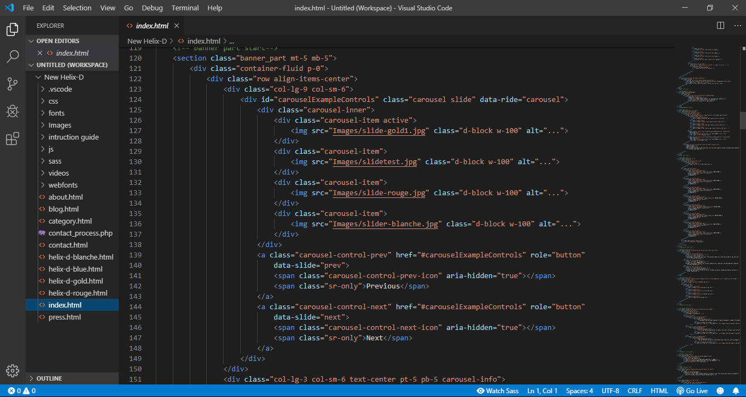

And this is the brand section slider same task.

